2025



|  |  |
| --- | --- |
| Name | Muhammad Taha Jamal |
| Registration Id | 2112244 |
| Section | BSCS 8th A |
| Course | Introduction to DevOps |
| Instructor | Tariq Khan Ghouri |



Lab 02 (Modules 01, 02, and 03)



Create, modify, and destroy resources.



Tariq Khan Ghouri



IT INFRASTRUCTURE, C



LOUD AND DEVOPS PROF



ESSIONAL



**Instruc(ons:**

1. Log in to Azure Portal with your credentials.
2. Paste all screenshots (highlighted in red) in a single Word document in the correct order.
3. Name the document as YourName-lab02.

**Lab Objec(ve:**

* Create, modify, and destroy resources.

**Lab Descrip(on:**

* Create a single Terraform script called lab02.U containing the following: o Provider and Terraform blocks. o Code to build the required infrastructure.
* Validate, deploy, expand, analyze, and destroy infrastructure.

# Part 1: Prepare for the Lab

1. Open a Command Prompt or PowerShell window.
2. Create a directory called lab02 in your home directory.
3. Change into the lab02 directory.
4. Create an empty file called lab02.U.

# Part 2: Codify the Following in a Single Terraform Script

Make sure to enclose values within double quotation marks.

5. Open lab02.U in a text editor (e.g., Notepad or Visual Studio Code) and define resource blocks as follows:

Define a resource group called lab02-rg using azurerm_resource_group.

Define a virtual network called lab02-vnet using azurerm_virtual_network.

Add a subnet to the virtual network called lab02-subnet1 using azurerm_subnet.

Define a network security group called lab02-nsg1 with an inbound allow TCP rule for port 22 called rule1 with priority 100 using azurerm_network_security_group.

A^ach the network security group lab02-nsg1 to lab02-subnet1 using azurerm_subnet_network_security_group_association.

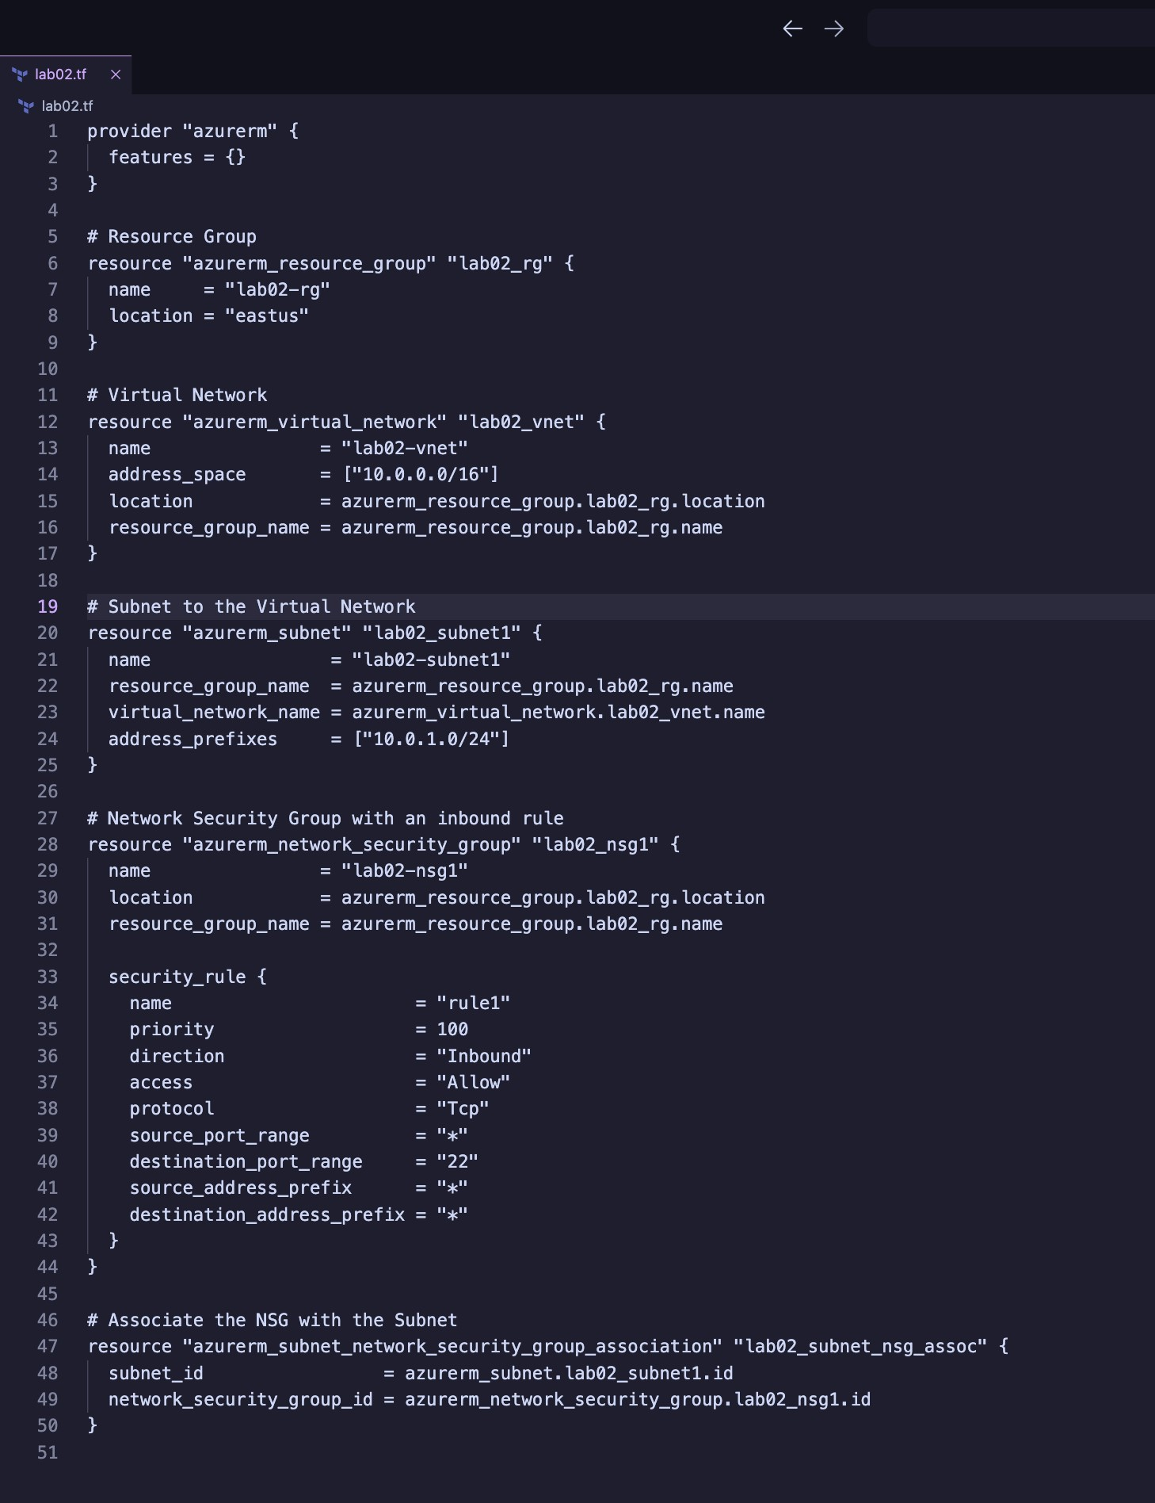

# Part 3: Initialize Terraform

1. Initialize Terraform and download plug-ins as required:

terraform init

1. View the content of the terraform.Ustate file:

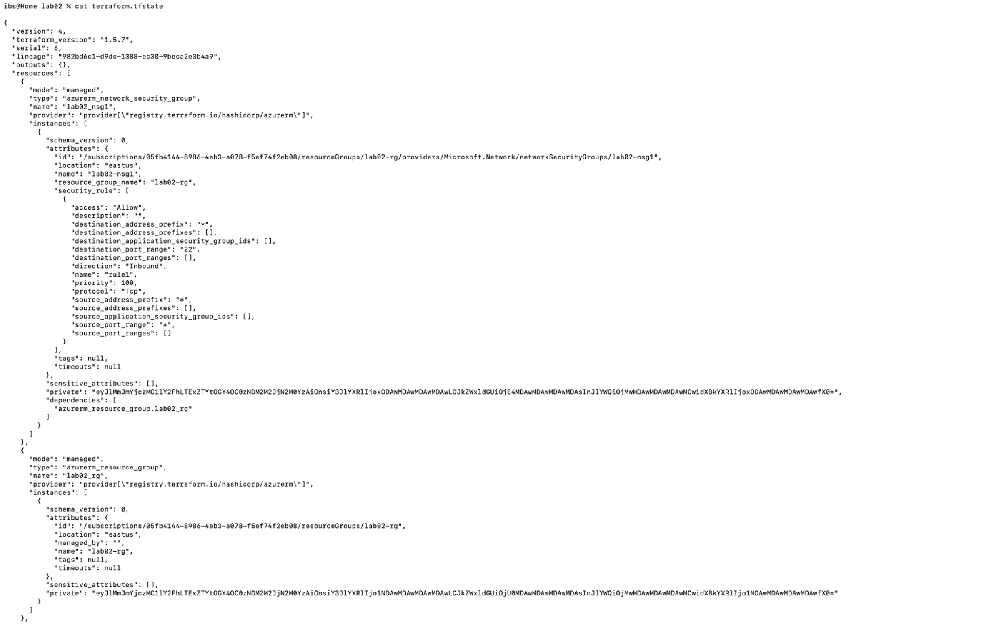type terraform..state

# Part 4: Validate Configuration

1. Validate the configuration to ensure there are no errors or typos in the file:

terraform validate

1. Fix any issues in the lab02.U file if reported (edit in your text editor).
2. Re-run the validation until no errors are reported.

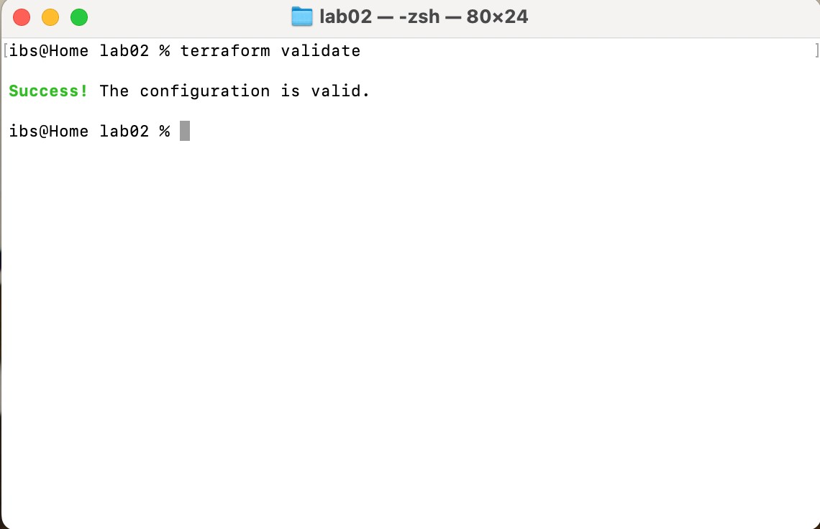

# Part 5: Run Simulation

1. Perform a dry run:

terraform plan

1. Review output and ensure all configuration is as per requirements. Observe the resources with +, -, or /+ signs.
2. Fix any issues in the lab02.U file if reported (edit in your text editor).
3. Redo the dry run until no errors are reported:

terraform plan

# Part 6: Deploy Infrastructure

15. Deploy the infrastructure and monitor progress:

terraform apply

o Type yes when prompted to confirm.

# Part 7: Get Information from Terraform State

16. View and analyze state information:

terraform state list terraform

show

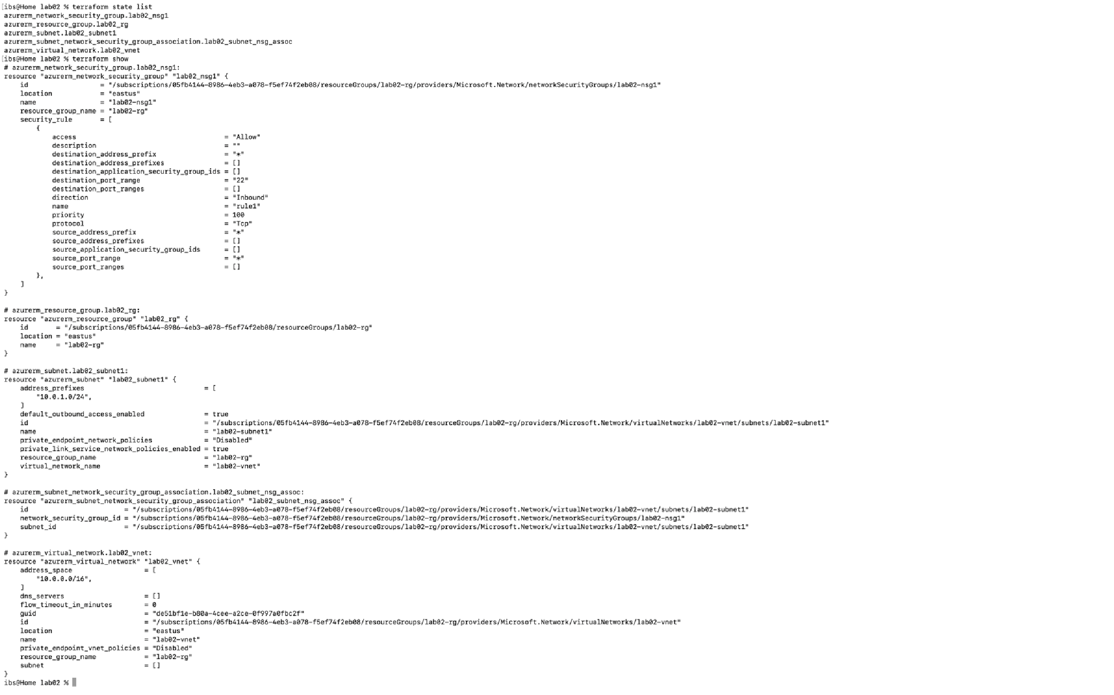

# 

# Part 8: Confirm Resource Creation in Azure

17. Log in to the Azure Portal. Navigate to the resource group and confirm all resources exist as per the specifications.

**SCREENSHOT** (capture the Azure Portal showing the resource group and resources).

20. Open lab02.U in your text editor and add the following:

1. Add another subnet to the virtual network called lab02-subnet2 using azurerm_subnet.
2. Define a network security group called lab02-nsg2 with two inbound allow TCP rules: o Port 3389 called rule1 with priority 100. o Port 5985 called rule2 with priority 200 using azurerm_network_security_group.
3. A^ach the network security group lab02-nsg2 to lab02-subnet2 using

azurerm_subnet_network_security_group_association.

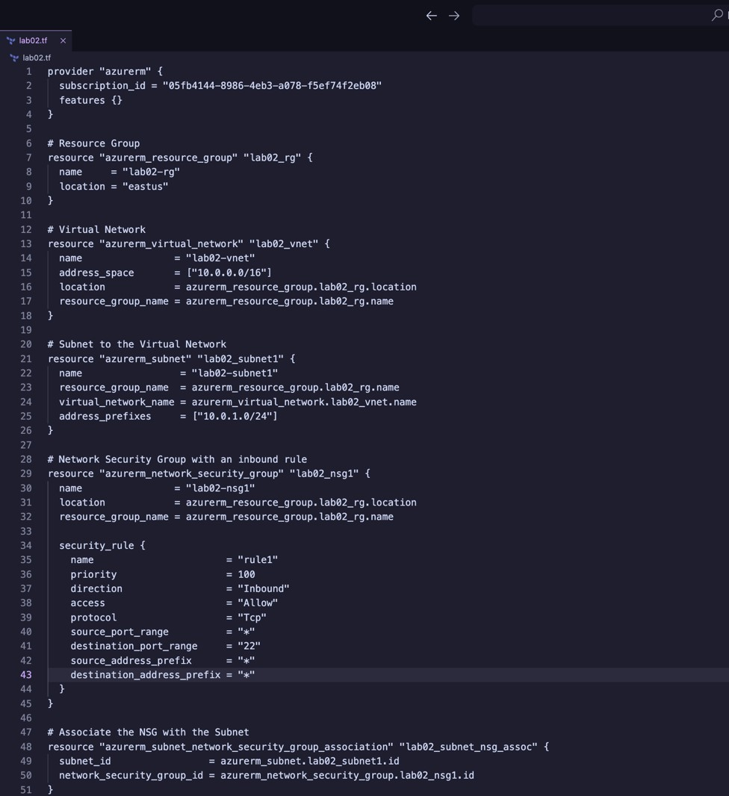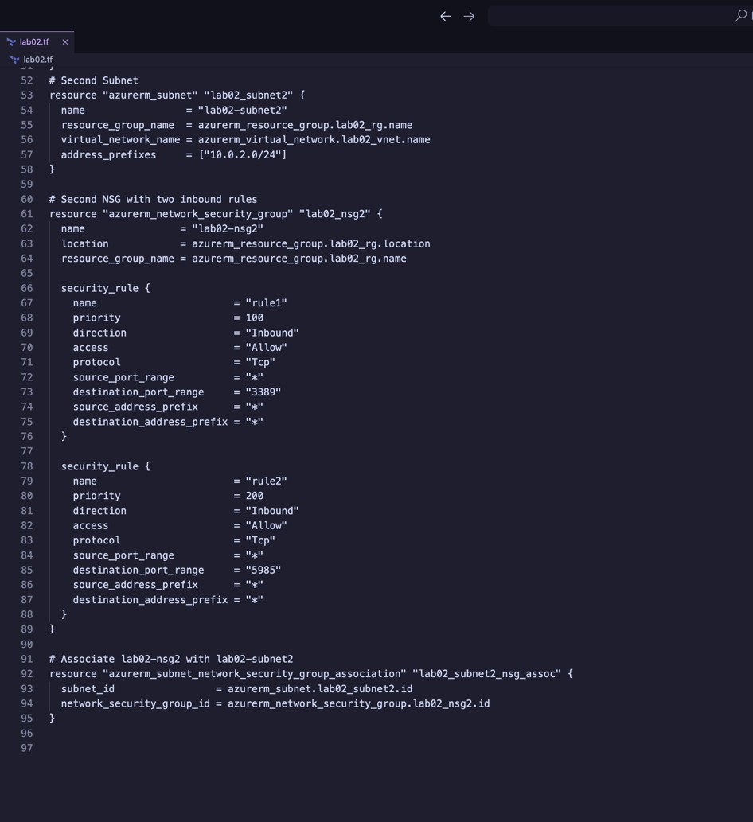

# Part 10: Validate Configuration

1. Validate configuration to ensure there are no errors or typos:
2. Fix any issues in the lab02.U file if reported.
3. Re-run the validation until no errors are reported:

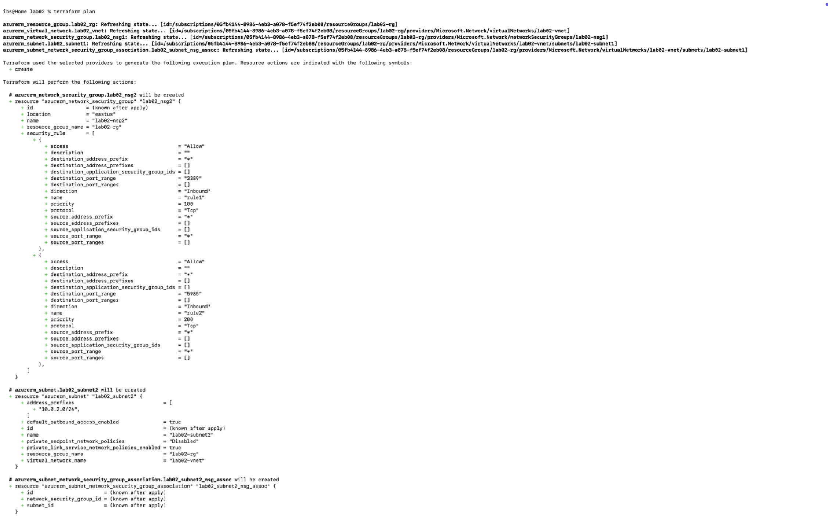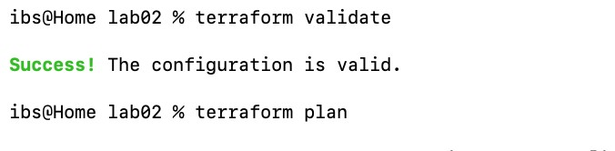

# Part 11: Run Simulation

1. Perform a dry run:

terraform plan

1. Observe output closely. Note resources with +, -, or -/+ signs.
2. Fix any issues in the lab02.U file if reported.
3. Redo the dry run until no errors are reported:

# Part 12: Deploy Infrastructure

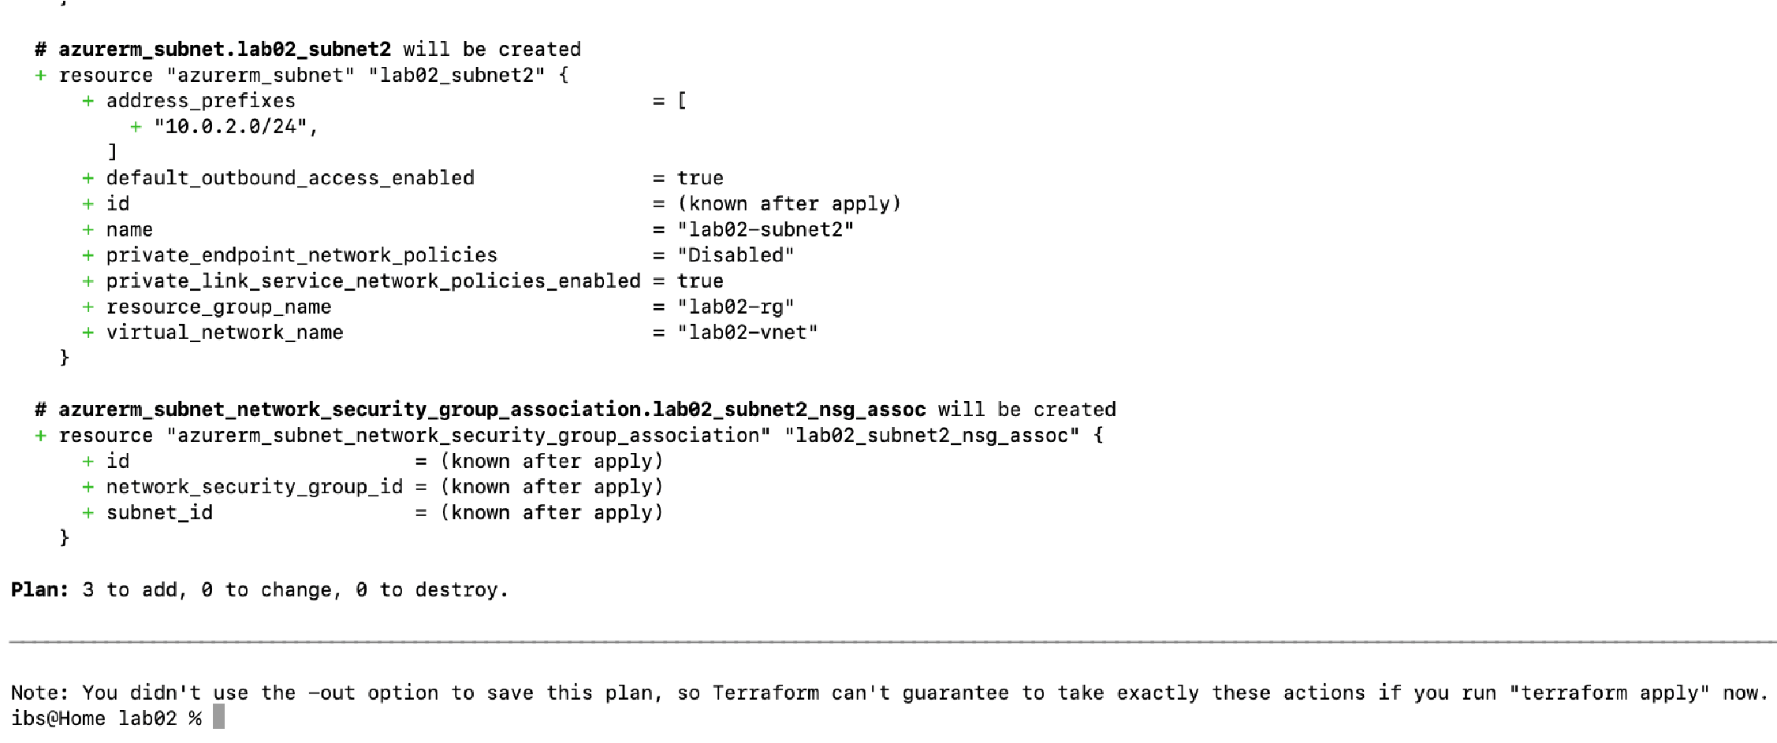

28. Deploy the infrastructure and monitor progress:

terraform apply

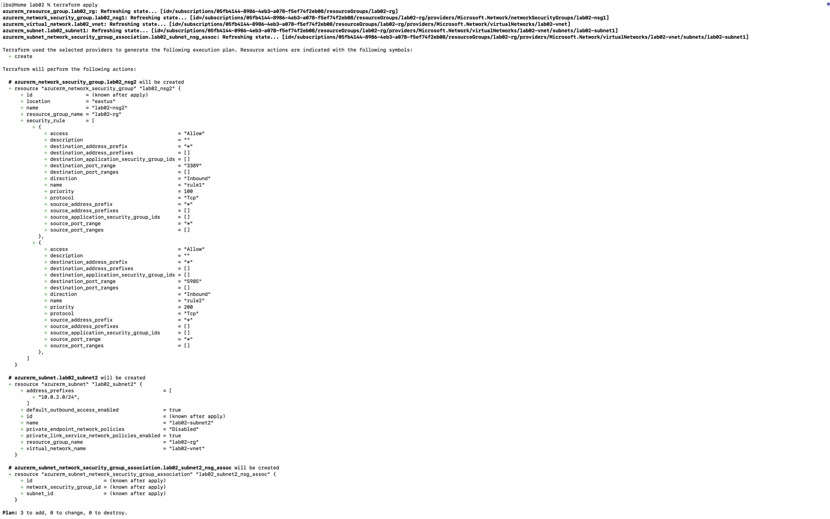 o Type yes when prompted.

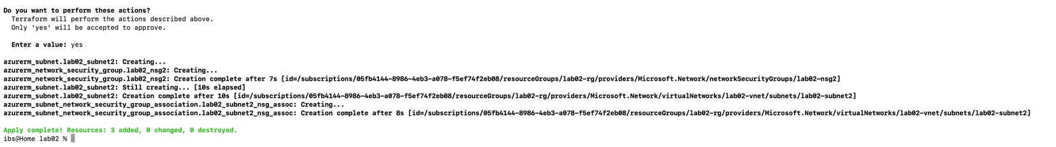

# Part 13: Get Information from Terraform State

1. View and analyze state information:

terraform state list

1. Log in to the Azure Portal. Navigate to the resource group and confirm all resources exist as per the specifications.

**Part 15: Destroy All Resources and Verify**

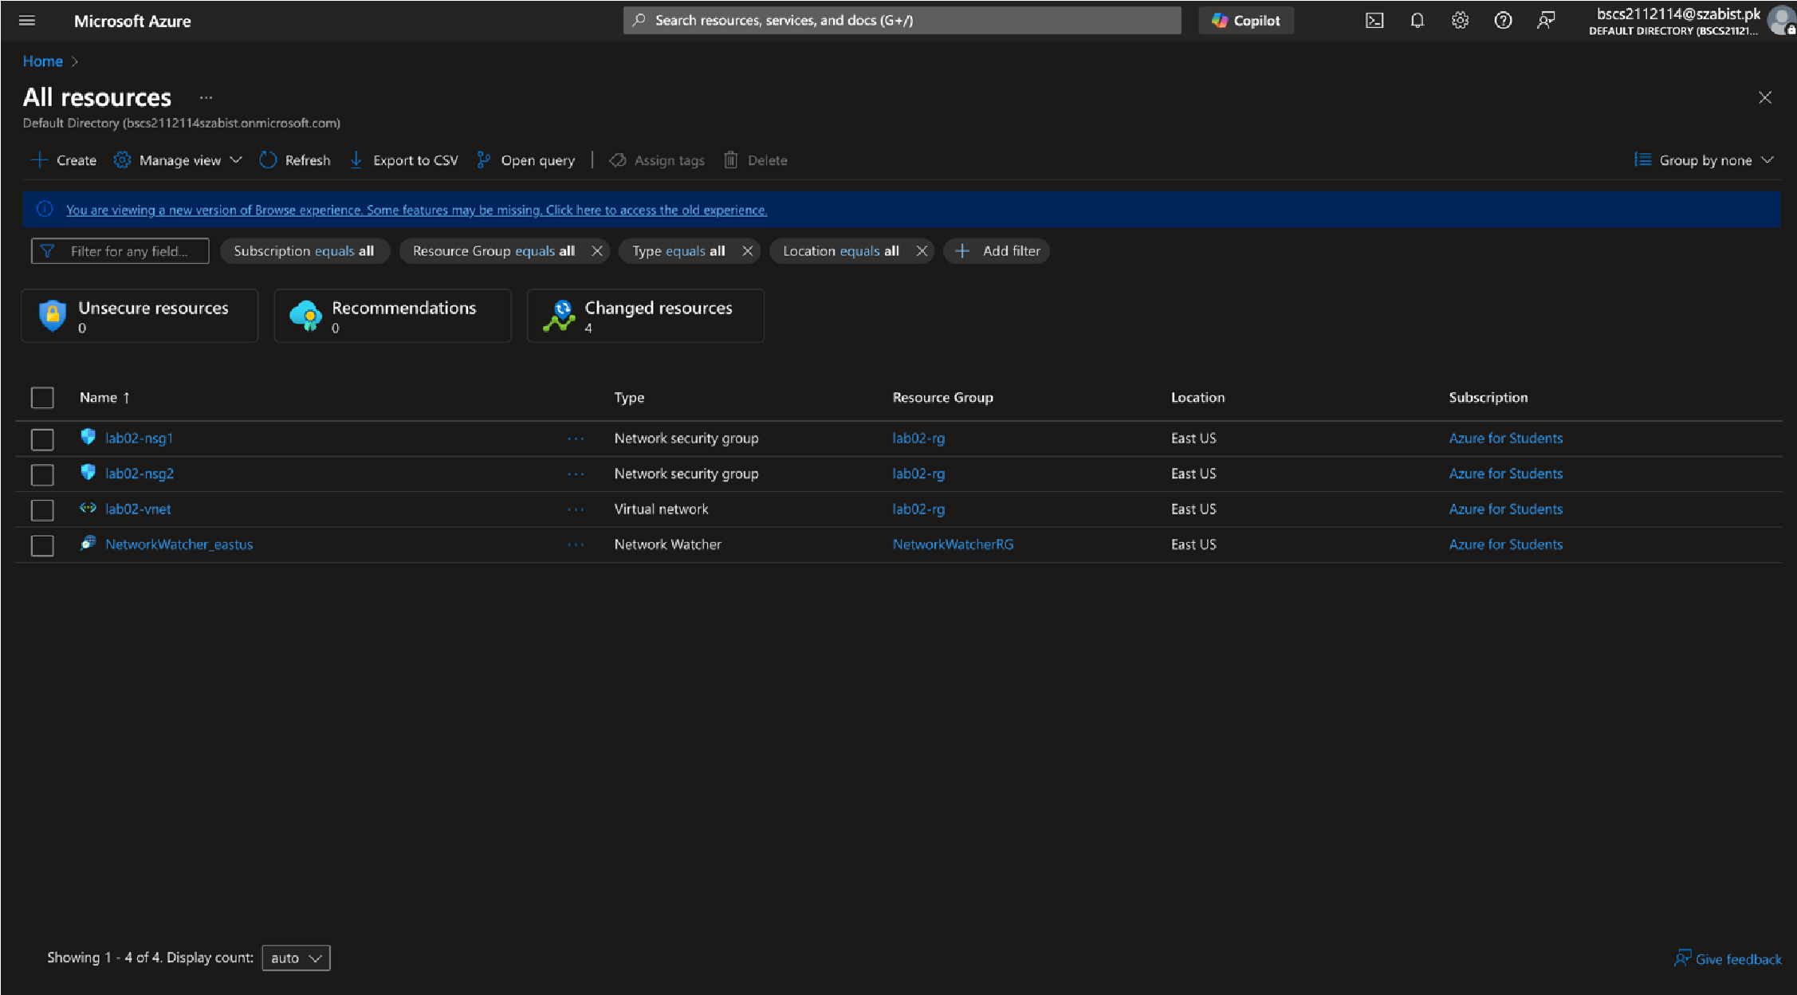

**Part 14: Confirm Resource Creation in Azure**

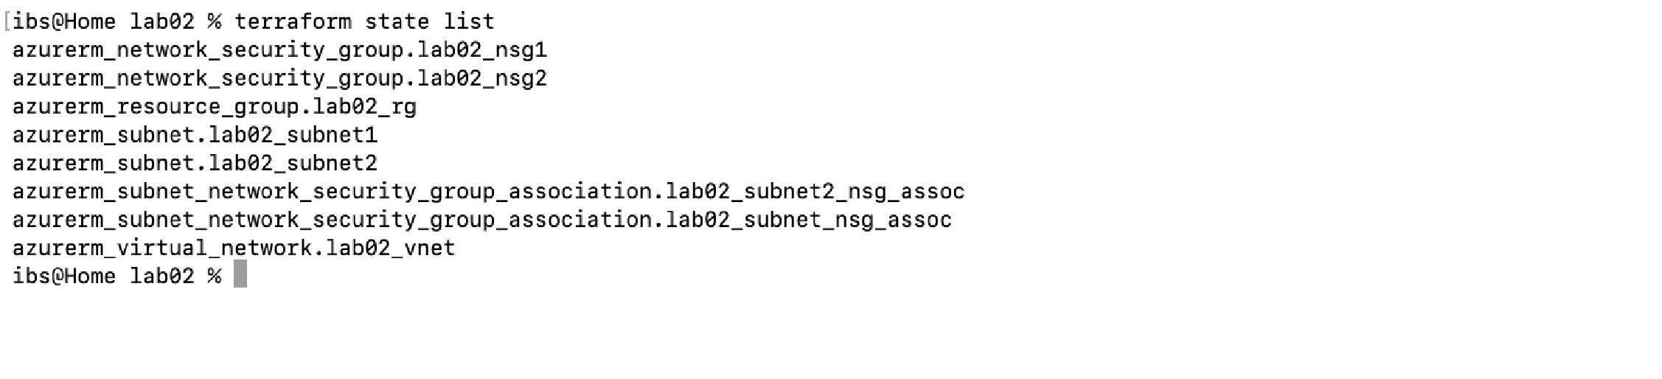

1. Destroy all the resources:

terraform destroy

o Type yes when prompted.

1. Verify deletion:

terraform state list

terraform show

